Recommended titles for Wellbeing Library: Primary

Title | Author | Description | RRP | Image
Starving the Anxiety Gremlin for Children Aged 5-9 | Kate Collins-Donnelly | The Anxiety Gremlin loves to eat anxious feelings, and the more anxious you feel, the more he eats and the bigger he gets! Learn how to get rid of the Anxiety Gremlin with this fun workbook for children aged 5-9. It's packed with puzzles, games, colouring and drawing activities to help children understand their anxiety and how to control it. | £12.99 | 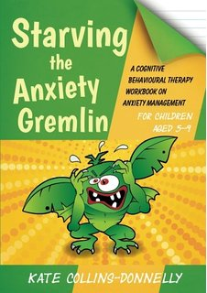
Starving the Anger Gremlin for Children Aged 5-9 | Kate Collins-Donnelly | The Anger Gremlin is a naughty creature who loves to feed on angry feelings, and the angrier you get, the bigger he gets! Packed with fun, simple activities and games, it will help children aged 5-9 understand why they get angry and how they can control their angry feelings to make the Anger Gremlin go away. Suitable for parents and practitioners | £12.99 | 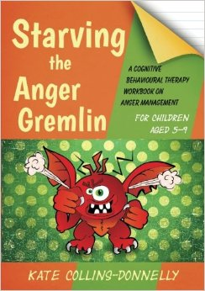
Can I tell you about Depression? | Christopher Dowrick and Susan Martin | This illustrated book is an ideal introduction to depression. Julie helps readers to understand what depression is, how it feels to be depressed and how it can affect their family life. She explains what help and support is available for people with depression and what friends and family can do to make things easier for her. | £8.99 | 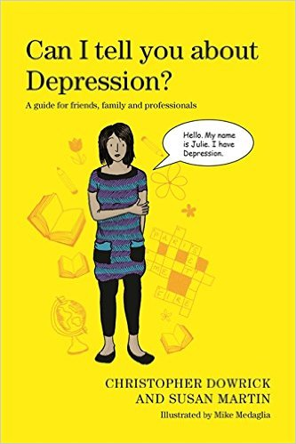
Can I tell you about Anxiety? | Lucy Willetts and Polly Waite | Megan invites readers to learn about anxiety from her perspective, helping them to understand why she sometimes feels anxious and how this affects her physically and emotionally. She talks about techniques she has learnt to help manage her anxiety, and tells family, friends and teachers how they can support someone who suffers from anxiety | £8.99 | 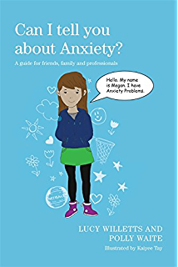
Can I tell you about Eating Disorders? | Bryan Lask and Lucy Watson | Alice invites readers to learn about how anorexia nervosa affects her daily life, and introduces Beth who has bulimia nervosa, Sam who has selective eating problems, Francesca who has functional dysphagia and Freddie who has food avoidance emotional disorder. They explain why they find food difficult and how their conditions are different. | £8.99 | 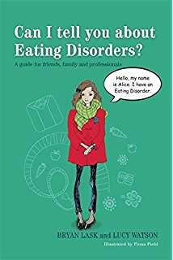
The big book of even more therapeutic activity ideas for children and teens | Lindsey Joiner | Full of activity ideas and projects to teach children and teens aged 5+ social skills, anger-control strategies, conflict resolution, positive thinking, and more, this book follows on from The Big Book of Therapeutic Activity Ideas for Children and Teens. It includes over 90 activities that are adaptable for use with individuals and groups. | £19.99 | 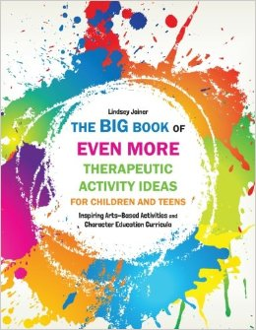
How to create kind schools | Jenny Hulme | This book tells the story of 12 innovative projects that schools across the UK are running which help to promote inclusion, tolerance and kindness and tackle issues such as homophobia, racism and truancy | £15.99 | 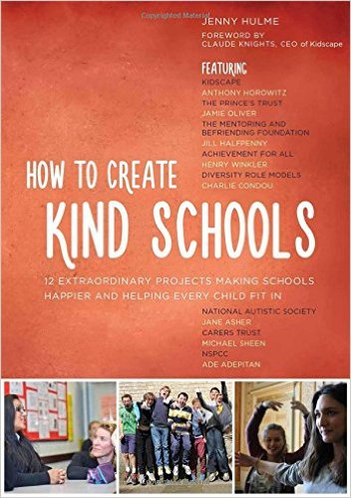
Making Your Secondary School E-Safe | Adrienne Katz | Cyberbullying, sexting, grooming and other online risks are a daily reality for teenagers so there is an increasing need to effectively teach e-safety in secondary schools. This practical teaching resource for school staff outlines policy and practice and provides ready-to-use activities to help schools meet Ofsted requirements for e-safety. | £22.99
Responding To Loss And Bereavement In Schools | John Holland | A complete resource to provide the best possible response to pupil and staff bereavement and loss in schools. Includes guidance on communication and the importance of considered whole-school support, audit and assessment tools, as well as a full set of photocopiable exercises for in-school training | £22.99 | 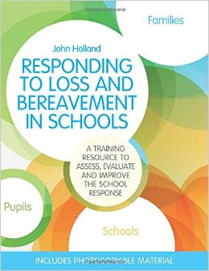
Essential Listening Skills For Busy School Staff | Nick Luxmoore | This accessible guide helps school staff members with the difficult issue of how to effectively listen and respond to pupils and staff in need of support. It covers questions such as 'what if I don't know what to say?', 'what if I don't have time?' and 'what about confidentiality?', as well as helping with issues such as bullying and self-harm | £10.99 | 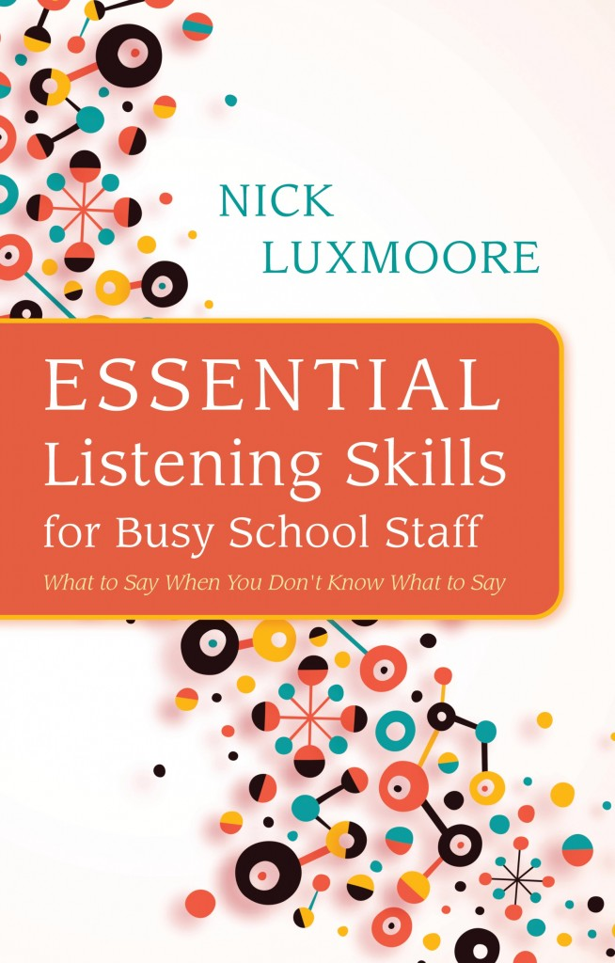
How Are You Feeling Today Baby Bear? | Jane Evans | This is the story of Baby Bear who lives in a home where the Big Bears have fights and arguments at night. A gentle therapeutic story to help children aged 2 to 6 years who have experience violence at the home to express and explore difficult feelings. | £9.99 | 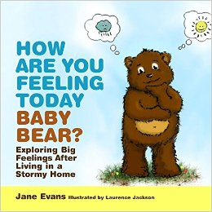
Alex and the Scary Things | Melissa Moses | This is the story of Alex who has experienced 'scary things', and the different things he does to cope with all the ways these scary things make him feel. This gentle storybook will help children who have experienced trauma deal with their emotions and learn coping strategies | £9.99 | 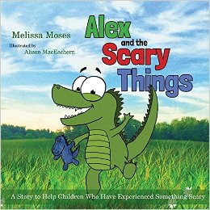
The Princess And The Fog | Lloyd Jones | This vibrantly illustrated story is designed to be read with children aged 5-7 who are suffering from depression. Using metaphor and full of humour, it is a relatable, enjoyable and positive read for all. The book also includes a guide for parents and carers by clinical paediatric psychologists, Dr Melinda Edwards MBE and Linda Bayliss | £10.99 | 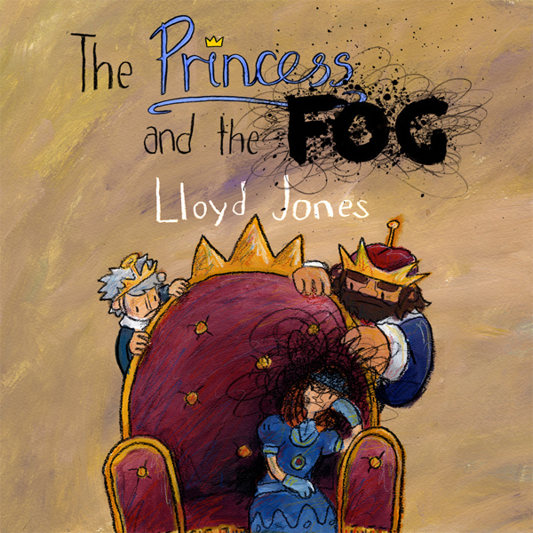
Not today, Celeste! | Liza Stevens | Charmingly illustrated, this heart-warming story for children aged 3+ reflects some of the feelings and experiences that a child whose parent or carer has depression may face | £10.99 | 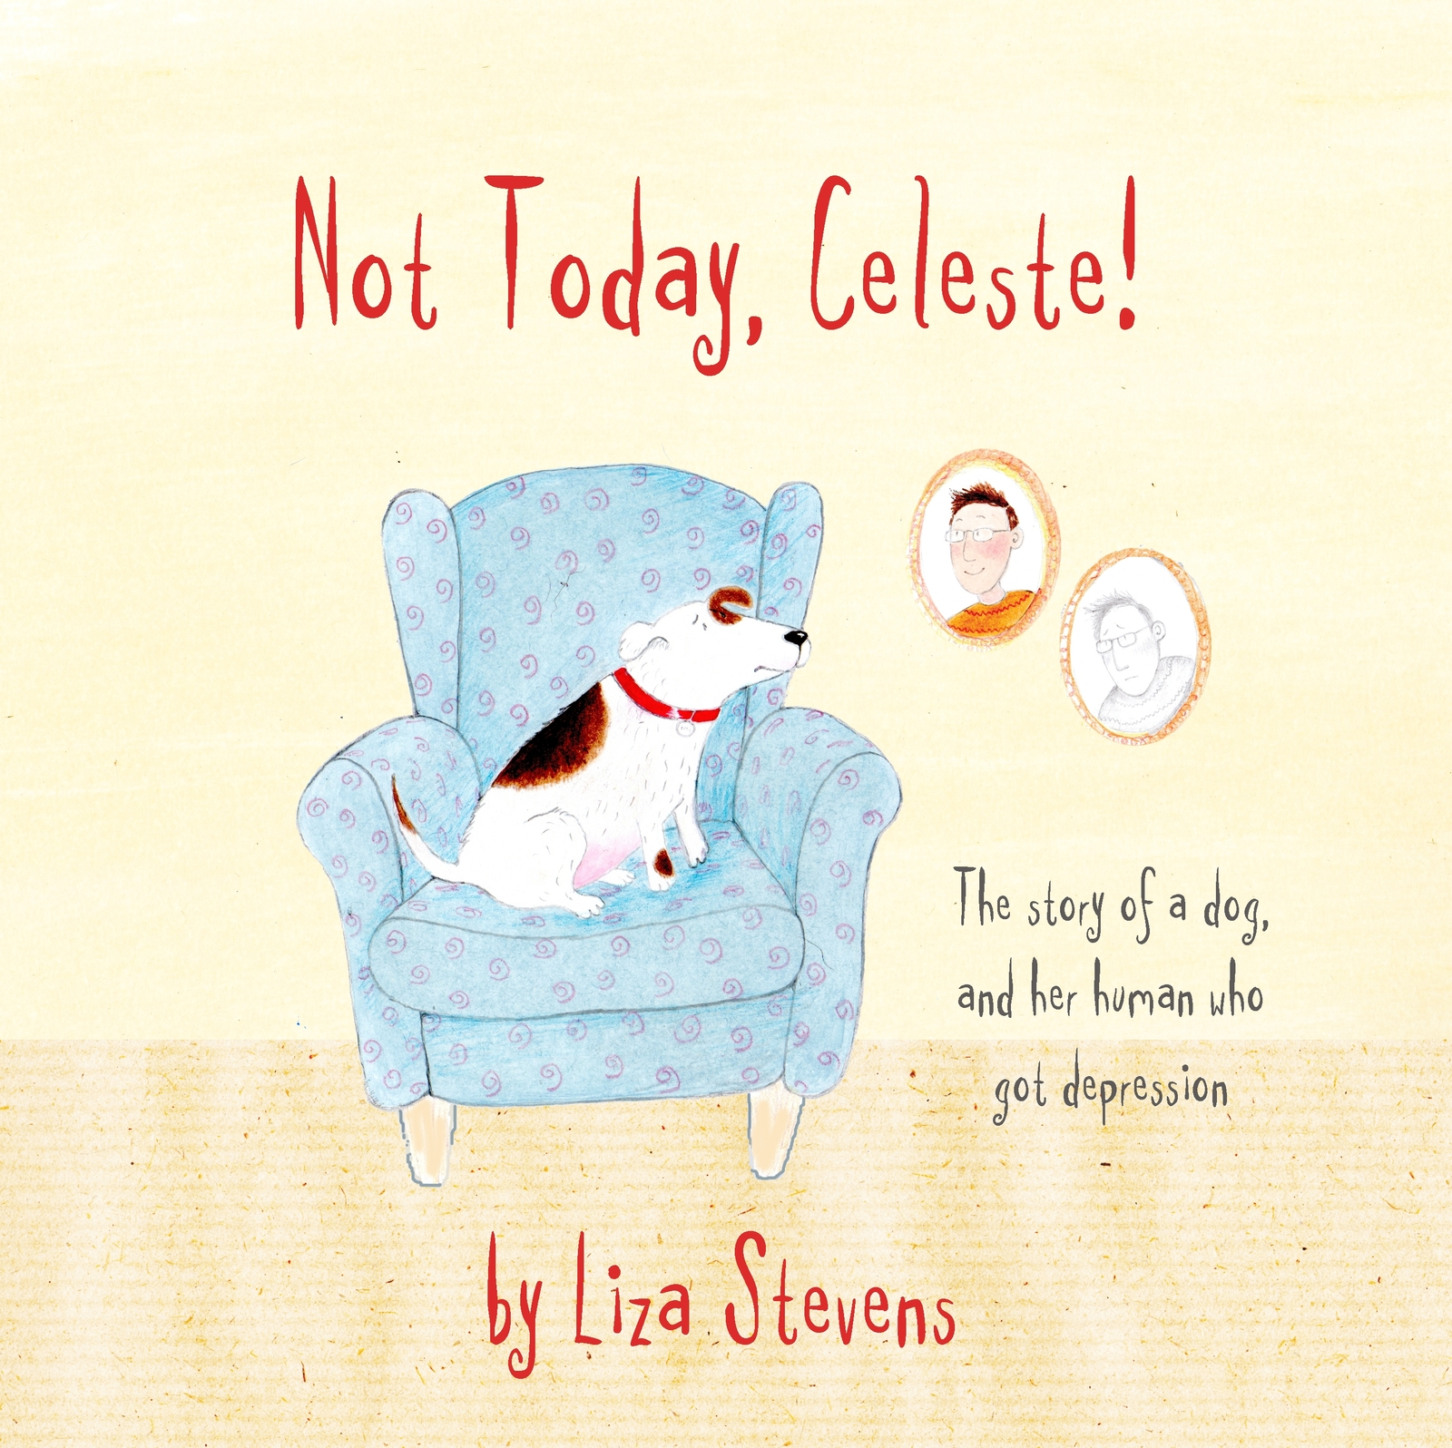
How to Be a Superhero Called Self-Control! | Lauren Brukner | Narrated by a superhero called Self-Control, this illustrated book provides a variety of super power strategies to help children with emotional and sensory regulation difficulties, aged approximately 4 to 7 years, to master self-control. | £12.99 | 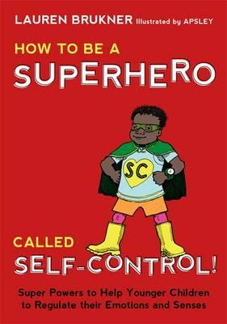
Your Body Is Brilliant | Sigrun Danielsdottir | The colourful illustrations in this picture book will help children learn to love their bodies from an early age and appreciate all the wonderful things their bodies do. The book promotes a healthy attitude which will help children understand that all bodies are different and encourage them to take good care of their bodies throughout their lives | £10.99 | 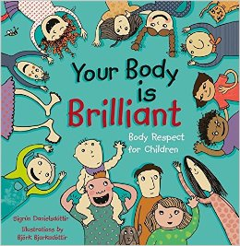
Ladybird's Remarkable Relaxation | Michael Chissick | Frog, Dog, Flamingo and Dragon are all very upset. Ladybird listens to their worries and comes up with a plan that will help them all – let's learn Ladybird's Remarkable Relaxation! This engaging picture book teaches an effective yoga relaxation technique that children can use anywhere and anytime to cope with anxiety, stress, grief, or bullying. | £12.99 | 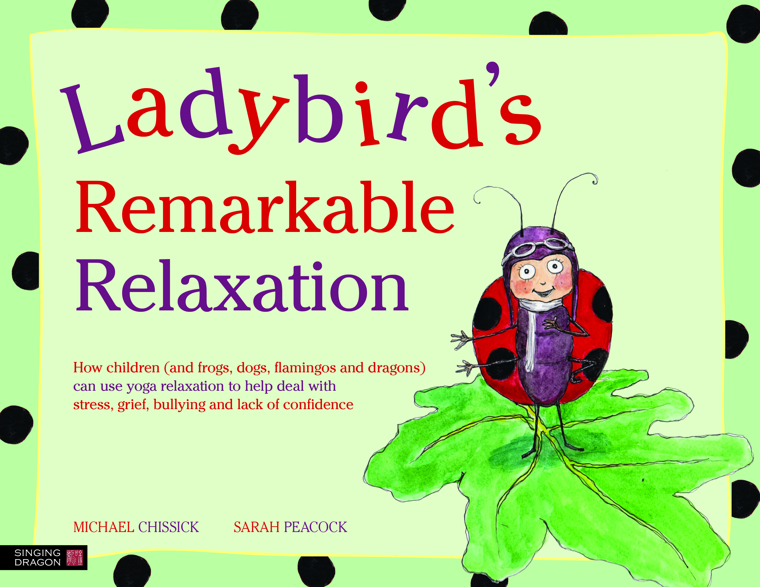
Seahorse's Magical Sun Sequences | Michael Chissick | Join Seahorse as he teaches the magical sun sequence to his friends, including Eel who uses a wheelchair and Crab who finds playing with others hard. This fun, engaging story teaches yoga to all children, with specific variations for different abilities, and helps them to cope with issues such as inflexibility and problems with self-esteem. | £12.99 | 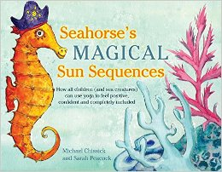

If you order one or more titles you can get a 20% discount with free postage and packaging

Order from www.jkp.com

Or contact Bookpoint
on 01256 400400
130 Milton Park, Abingdon, OX14 4SE

using discount code UKLIB

This list was created in partnership with Jessica Kingsley Publishers www.jkp.com

The Charlie Waller Memorial Trust, is a charity that provides fully-funded mental health training talks, and resources to young people and those who work with or care for them.

