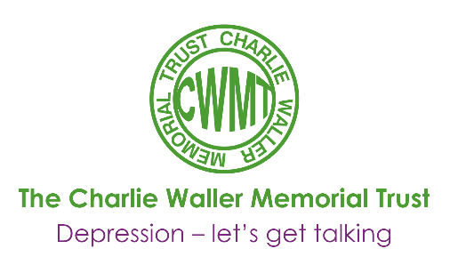
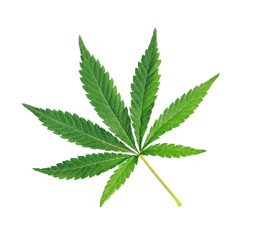

‘Highs’ and Lows: the link between cannabis use and depression
Andrew Jones & Matt Field

Cannabis is the most widely used illicit drug in Western Europe, the USA and Australia. It is estimated that over the last 20 years the proportion of young adults that use cannabis has increased dramatically. The most recent statistics indicate that 30% of people aged 16-59 in the UK have ever used cannabis, and about 10% reported using it in the last year. The acute psychological effects of cannabis, produced by the compound THC (tetrahydrocannabinol) are well documented, and they include euphoria, and an altered state of consciousness. However, there is a cloud of smoke which obscures our understanding of the effects of regular cannabis use over a long period of time (the chronic effects).
The scientific literature suggests that there is an association between cannabis use and depression. Evidence from clinical populations (individuals being treated for depression), suggests they are more likely to use cannabis than non-depressed individuals. Furthermore, within people who are suffering from depression, the frequency of cannabis use is associated with the severity of their depressive symptoms. It is important to examine whether the link between cannabis use and depression is also seen in people who are not being treated for depression, because there is good evidence that many people who suffer from depression never seek treatment for it. In community samples the association between cannabis use and depression is further supported: Two large surveys in the USA found significant co-morbidity (the joint presence) of cannabis use and mood disorders. Therefore, it seems fairly clear that cannabis use and depression are associated with each other, and we see this link in the population at large – it is not just confined to the most severely depressed people.
So, it seems that there is an association between cannabis use and depression, but what is the direction of this relationship? The old statistics adage ‘correlation does not imply causation’ is especially relevant here. In order to treat or prevent depression or the abuse of cannabis we must target the causes, but in order to do so we must discover whether depression leads people to smoke cannabis, or if smoking cannabis leads to the development of depression. Causal relationships between variables can be identified through a number of tests. Firstly, the variables must be associated with each other, and in the case of cannabis use and depression, they do seem to be. Next, we must establish something known as ‘temporal priority’, meaning that the cause should be shown to occur before the outcome. The most crucial test of causality is ‘direction’, which means that we have to investigate whether any change in the (suspected) cause will lead to a change in the outcome. If we apply these criteria to understanding the link between cannabis use and depression, we can get a better handle on what causes what.
The first possibility to consider is that depression pre-dates and causes people to smoke cannabis. This could be framed as a ‘self-medication’ hypothesis. The ‘selfmedication’ hypothesis suggests that individuals who are experiencing psychological distress (e.g. depression), seek to alleviate their symptoms through use of specific psychoactive drugs. As mentioned previously the acute effects of cannabis are euphoria and relaxation, making it, in theory, an ideal drug to counter depressive symptoms. Indeed, depressed patients who use cannabis may report that they use the drug in order to alleviate their symptoms, and some studies suggest that low doses of smoked cannabis may indeed have anti-depressant qualities. However, other types of evidence are not consistent with this. For example, people who suffer from depression appear to be less sensitive to the pleasant effects of cannabis, and cannabis at very high doses may even induce depressive states. In addition, longitudinal studies with adolescents suggest that people who were depressed during adolescence are no more likely to use cannabis in later life than people who were not depressed as adolescents. Therefore, the idea that depression causes people to become regular cannabis users is not well supported by the evidence.
If depression does not seem to cause cannabis use, what about the other possibility: does cannabis use cause depression? One longitudinal study followed a large sample of adults over a fifteen year period, and found that cannabis use led to a fourfold increase in the risk of developing major depression later on in life, even after controlling for other factors which are known to be associated with both cannabis use and depression such as household income, stress and use of other substances. In this study, the use of cannabis exacerbated anhedonia (the inability to gain please from activities usually pleasurable), and suicidal inclinations. Furthermore, the relationship between cannabis use and depression was shown to be dosedependent: as the frequency of cannabis use increased, the likelihood of developing depression later on in life also increased.
Whilst the evidence that cannabis use may increase risk of depression is stronger than the evidence showing the opposite (that depression causes cannabis use), we must be careful not to overstate the relationship. For example, while a fourfold increase in major depression among people who use cannabis looks worrying, the incidence of depression was very low, and around 96% of people who smoked cannabis did not go on to develop major depression, which suggests that cannabis plays a modest role in causing depression. This is not to say that heavy cannabis use should be ignored as a factor which contributes to depression, but we must acknowledge that many factors can contribute to the development of depression (e.g. genetics, unemployment, life stressors), and cannabis is only one of them.
The aim of this article was to explain the link between cannabis and depression, a task which proved most difficult when considering all of the available evidence. We can certainly conclude that cannabis use and depression are associated with each other, and that cannabis use may increase the risk of depression over time. The relationship between the two is likely complicated by many societal factors and differences between people, and numerous other factors we couldn’t squeeze into this short piece. Consequently, the only straightforward conclusion we can offer is that the relationship between cannabis use and depression is not straightforward. Future research will no doubt identify additional social and biological causes of depression, and we will get a better understanding of how cannabis use fits in.

Andrew Jones and Matt Field, Institute for Psychology, Health and Society, University of Liverpool, UK.

This article featured in the CWMT Newsletter, issue 26, September 2012

