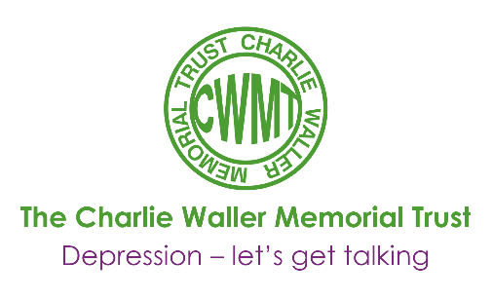

Suicide and deliberate self- harm in young people
Keith Hawton & Anthony James

Keith Hawton - Professor of Psychiatry and Director of the Centre for Suicide Research at the University of Oxford, and Consultant Psychiatrist at Oxfordshire Mental Healthcare Trust, Warneford Hospital, Oxford.
Anthony James - Consultant in Adolescent Psychiatry at the Highfield Adolescent Unit, Oxfordshire Mental Healthcare Trust, Warneford Hospital, Oxford.
Deliberate self harm ranges from behaviours with no suicidal intent (but with the intent to communicate distress or relieve tension) through to suicide. Some 7%-14% of adolescents will self harm at some time in their life, and 20%-45% of older adolescents report having had suicidal thoughts at some time.
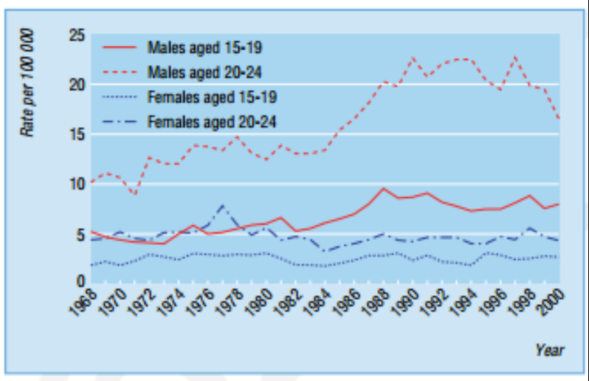Suicide and undetermined deaths in England and Wales in 15-19 year olds and 20-24 year olds between 1968 and 2000. Data source: Office for National Statistics. Twentieth century mortality: 100 years of mortality data in England and Wales by age, sex, year and underlying cause. CD Rom. London: ONS, 2003.

Suicide
Suicide occurs relatively rarely under the age of 15 years although prevalence is likely to be underestimated because of reluctance of coroners to assign this verdict. A large proportion of open verdicts (“undertermined cause”) are, in fact, suicides. Suicide rates are far higher in male than female adolescents. Until the past five or six years in England and Wales suicide rates were rising substantially in 15-19 year old and 20-24 year old young men, but then they began to fall somewhat in the older age group. The lack of change in female suicide rates may reflect differential effects of social change on gender roles.
Possible reasons for rise in male suicide rates in United Kingdom:
- Increased rates of family breakdown
- Increasing rates of substance misuse
- Increasing rates of depression
- Greater instability of employment
- Increased availability of means for suicide
- Media incluences (though to contribute to 5% of suicides in adolescents)
- Awareness of suicidal behaviour in other young people
Psychological postmortem studies show that a psychiatric disorder (usually depression, rarely psychosis) is present at the time of death in most adolescents who die by suicide. A history of behavioural disturbance, substance misuse, and family, social and psychological problems are common. There are strong links between suicide and previous self harm: between a quarter and a half of those committing suicide have previously carried out a nonfatal act.
Common characteristics of adolescents who die by suicide:
- Broken homes (separation, divorce, or death of parents)
- Family psychiatric disorder or suidical behaviour
- Psychiatric disorder or behavioural disturbance
- Substance misuse (alcohol or drugs)
- Previous self harm

Common Expressions of parental grief after suicide by adolescents
- Refusal to accept that the death was a suicide
- Anger towards friends of the deceased, family members, medical staff, coroners, and even the deceased person
- Guilt
- Shame
- Constant search for explanation
- Fear of welfare of other children; overprotection
- Disruption of relationship with partner
- Stigmatisation
- Depression or suicidal ideation
- Alcohol misuse
General practitioners, bereavement counsellors, support organisations and the clergy have important roles in providing support and facilitating grief.

Deliberate self harm
Possible motives or reason underlying self hard
- Ro die
- To escape from unbearable anguish
- To change the behaviour of others
- To escape from a situation
- To show desperation to others
- To “get back at” other people or make them feel guilty
- To gain relief of tension
- To seek help
The term deliberate self harm is preferred to “attempted suicide” or “parasuicide” because the range of motives or reasons for this behaviour includes several non-suicidal intentions. Although adolescents who self harm may claim they want to die, the motivation in many is more to do with an expression of distress and desire for escape from troubling situations. Even when death is the outcome of self harming behaviour, this may not have been intended.
Most self harm in adolescents inflicts little actual harm and does not come to the attention of medical services. Self cutting is involved in many such cases and appears to serve the purpose of reducing tension or of self punishment. By contrast, self poisoning makes up about 90% of cases referred to hospital. The substances involved are usually readily available in the home or can be bought over the counter and include non-opiate analgesics –– such as paracetamol and aspirin –– and psychotropic agents. Self harm by more dangerous methods, such as attempted hanging, may be associated with considerable suicidal intent.
Common problem preceding self harm
- Difficulties or disputes with parents
- School or work problems
- Difficulties with boyfriends and girlfriends
- Disputes with siblings
- Physical ill health
- Difficulties or disputes with peers
- Depression
- Bullying
- Low self esteem
- Sexual problems
- Alcohol and drug abuse
- Awareness of self harm by friends or family
Risk Factors
Common characteristics of adolescents who self harm are similar to the characteristics of those who commit suicide. Physical or sexual abuse may also be a factor. Recently there has been increasing recognition of the importance of depression in non-fatal as well as fatal self harm by adolescents. Substance misuse is also common, although the degree of risk of self harm in adolescents attributable to alcohol or drug misuse is unclear. Knowing others who self harm may be an important factor.
Young South Asian females in the United Kingdom seem to have a raised risk of self harm. Intercultural stresses and consequent family conflicts may be relevant factors.
As many as 30% of adolescents who self harm report previous episodes, many of which have not come to medical attention. At least 10% repeat self harm during the following year, with repeats being especially likely in the first two or three months.
The risk of suicide after deliberate self harm varies between 0.24% and 4.30%. Our knowledge of risk factors is limited and can be used only as an adjunct to careful clinical assessment when making decisions about after care. However, the following factors seem to indicate a risk: being an older teenage male; violent method of self harm; multiple previous episodes of self harm; apathy, hopelessness, and insomnia; substance misuse; and previous admission to a psychiatric hospital.
Factors associated with repeated self harm
- Previous self harm
- Personality disturbance
- Depression
- Alcohol or drug misuse
- Chronic psychosocial problems and behaviour disturbance
- Disturbed family relationships
- Alcohol dependence in to family
- Social isolation
- Poor school record
Self harm is frequently a highly impulsive act –– many individuals report that they had thought about the act for just minutes before doing it. Alcohol and drug consumption probably increases the likelihood of impulsive acts.

Prevention
It can be difficult to identify younger people at risk of self harm, even though many older adolescents who are at risk consult their general practitioners before they self harm. Suicidal ideation is relatively common among adolescents; precipitating events may be nonspecific; acts of self harm are often impulsive; and secrecy and denial are common. Effective preventative care requires involvement of multiple agencies –– for example, mental health services and social services. These agencies need to work in a coordinated way with adolescents thought to be at risk, including those with severe psychiatric disorders.
Groups at risk who may benefit from preventive strategies
- Depressed adolescents (depression may be less easy to identify in adolescents than in adults because of atypical presentation, such as behavioural disturbance poor school performance, and social withdrawal)
- Those with an interpersonal crisis, such as loss of a partner or running away from home
- Those who have previously self harmed, particularly if substance misuse and conduct disorder are present.

Assessment after self harm
All young people who have self harmed in a potentially serious way should be assessed in hospital by either a child and adolescent psychiatrist or a specialist mental health worker, psychologist, psychotherapist, or psychiatric nurse. This is necessary for the management of the medical issues and to ensure the young person receives a thorough psychosocial assessment.
Features of self harm that suggest high suicidal intent
- Conducted in isolation
- Timed so that intervention is unlikely (for example, after parents have gone to work)
- Precautions to avoid discovery
- Preparations made in anticipation of death (for example, leaving indication of how belongings to be distributed)
- Adolescent told other people beforehand about thoughts of suicide
- The act had been considered for hours or days beforehand
- Suicide note or message
- Adolescent did not alert others during or after the act
The clinician can improve his or her examination by using a semistructured assessment. The natural starting point is inquiry about the events leading up to the act.
Important issues in assessment of adolescents who have self harmed
- Events surrounding the overdose or self harm
- Degree of suicidal intent and other reasons for the act
- The adolescent’s current problems
- Possible psychiatric disorder
- Family and personal history
- History or psychiatric disorder or self harm
- The nature or the adolescent’s resources and supports
- Risk of further self harm and of suicide
- Attitudes towards help
It is essential to establish whether the young person had a high degree of suicidal intent. As denial of intent is sometimes a problem, it is important to get as detailed an account of the circumstances as possible and compare these to factors known to be associated with high intent. Sometimes the reasons for self harm seem unclear because the act may seem highly impulsive. The clinician must therefore use all the information available to try to understand the motivation. This should involve exploring the adolescent’s concept of death –– asking, for example, what they expected to happen and whether they had thought they would still be around afterwards to see the consequences of the act. Suicidal intent tends to be associated with depression and hopelessness.
The physical severity of the self harm is not a good indicator of suicidal intent because adolescents are often unaware of the relative toxicity of supposedly harmless substances such as paracetamol. Similar issues in the young person and their family can be usefully assessed in primary care in cases of less serious self harm
Assessment of families of young people who seriously self harm
- Family structure and relationships
- History of psychiatric disorder, including suicide attempts in the family
- Recent family life events, especially losses
Assessment of family’s support and problem solving ability
- Inquire about the circumstances of the self harm, events leading up to it, and how it has affected the family
- Inquire about how the family has tackled serious problems in the past

Treatment
Treatment options for adolescent self harm

Individual
- Problem solving
- Cognitive behavioural therapy
- Treatment of underlying psychiatric disorder (such as antidepressants or CBT)
- Treatment of drug or alcohol abuse
- Anger management
Family
- Family therapy (such as problem solving or structural or systemic therapy)
Group
- Group therapy (including problem solving, CBT, and dealing with developmental concerns and emotions)
Others
- Environmental changes (such as temporary alternative accommodation)
Most adolescents who self harm do so in response to interpersonal crises and can be discharged for treatments as outpatients. Inpatient psychiatric treatment is usually reserved for those who have severe depressive or psychotic disorder, present an ongoing risk of suicide, or are in the middle of major psychosocial difficulties, such as disclosure of sexual abuse.
A crisis intervention model is often most appropriate. Compliance, however, can be a problem because the self harm may have had a positive effect by providing temporary relief from a difficult situation. Also the take-up of treatment depends largely on parental background and attitudes, which may include denial and negative views about psychological help. A home based treatment programme may overcome some of these problems.
Problem solving therapy is often used with adolescents and has the advantage of being direct and easily understood. Using problem solving techniques and rehearsing coping strategies can help the adolescent when he or she is confronted with future crises.
The problem solving approach can also be extended to involve the whole family. Family interventions are structured, usually last five or six sessions, and can be home based. Essential elements include the improvement of specific cognitive and social skills to promote the sharing of feelings, emotional control, and negotiation between family members. Role play can be a useful additional technique. It is wise to anticipate crises by making provisions for appointments at short notice or giving telephone numbers for emergencies. Adolescents who self harm can also be treated in groups.
If depression is present, cognitive behaviour therapy is an effective treatment in adolescents. The selective serotonin reuptake inhibitor fluoxetine (Prozac) is effective in this age group. However, in view of the risk of further self harm by overdose, it is wise to limit supplies of this drug and get other family members to handle it, at least intially.
If school problems, particularly bullying, are prominent, liaison with the school is important. Further help may be provided by a school counsellor. In the case of learning difficulties, an assessment by an educational psychologist may be helpful in devising suitable educational options.
When the self harm occurs alongside substance and alcohol misuse or violence, specific treatments for these conditions may be indicated. For older adolescents, referral to a self help agency or walk-in counselling service may be appropriate –– and more readily accepted.
Basics of problem solving therapy
- Identifying and deciding which problem(s) to tackle first
- Agreeing goals
- Working out steps to achieve goals
- Working out steps to achieve goals
- Deciding how to tackle the first step
- Reviewing progress
- Dealing with psychological factors that obstruct progress
- Working through subsequent steps

Reproduced with kind permission of the authors and the British Medical Journal

This article featured in the CWMT Newsletter, issue 16, October 2007

