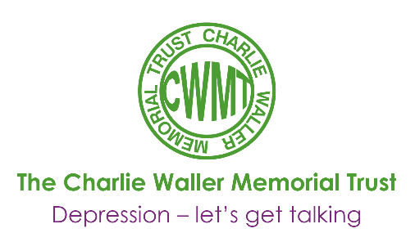

Exercise for anxiety
Drs Michael Otto & Jasper Smits

Worries, panic attacks, avoidance, difficulties sleeping, upset stomachs, muscle tension, obsessions, and sweating: the symptoms of anxiety are both varied and pervasive. Anxiety hurts relationships, decreases quality of life, curbs job attainment, and impairs social functioning. Bad anxiety needs good treatment.
Clinical studies document reliable benefits from at least two types of treatment for anxiety disorders: cognitive-behaviour therapy and medication treatment. Yet, as everyone knows, no one treatment works for neither everyone, nor does one treatment fit everyone. More treatment choices are needed, both for clinical anxiety as well as for the anxieties that nag us in everyday life. Fortunately, there is increasing evidence for the value of exercise for treating both clinical anxiety disorders as well as more general difficulties with anxiety.
Almost 50 studies have been performed outside the psychiatric clinic, examining the effects of programmed exercise on anxiety as it arises in individuals with medical complaints, among the elderly, after stress, or in the general population. In all of these applications, it is clear that regular leisure-time exercise can offer reliable benefits of exercise for anxiety disorders. In these programs, exercise in the range of 30-40 minutes was assigned three times per week. To date, the best studies have been conducted for panic disorder and obsessive-compulsive disorder. In one such study, 10 weeks of a program of this offered patients with panic disorder almost the same benefit as treatment with the drug, clomipramine. There is also evidence that exercise, when added to a program of cognitivebehaviour therapy for panic disorder, social phobia, or generalized anxiety, can offer additional benefits - extending the gains offered by therapy.
More research studies of this kind are underway, with the hope of documenting both the range and time course of benefits from exercise. And like exercise for a depressed mood, it isn't that you have to wait 10 weeks for a benefit. For individuals feeling anxious, reductions in state anxiety are often found within 10 minutes of completing exercise.
So, while researchers try to pull together even more evidence of the mood benefits of exercise, do all those things that help you cope with anxiety-talk with a friend, do active problem solving, take a meaningful break, write out your concerns, see a therapist-but also consider the additional value that might be offered by regular, 30 minutes bouts of moderate exercise.

Copyright Michael Otto
Drs. Michael Otto and Jasper Smits are authors of Exercise for Mood and Anxiety Disorders: Proven Strategies for Overcoming Depression and Enhancing Well Being

This article featured in the CWMT Newsletter, issue 26, September 2012

