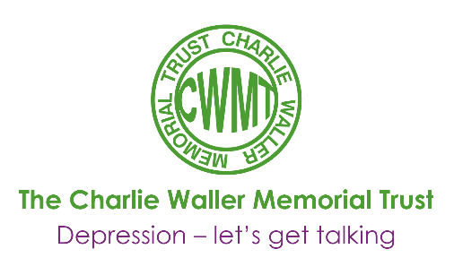
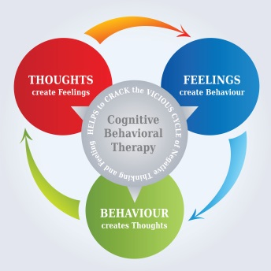

What exactly is cognitive behaviour therapy?
Mary Bennett

Most people with an interest in Depression are aware that Cognitive Behaviour Therapy is the recommended treatment for depression, either as an alternative to medication or as an additional intervention. However not everybody is clear about what it is. This short article sets out to define CBT and to introduce some of the basic techniques used in this type of therapy.
The invention of Cognitive Therapy is attributed to Aaron Beck who in the 1970s analysed the thought content of his patients and noted the unhelpful and negative thought patterns they held. He postulated that such thoughts could in themselves lower mood, produce physical symptoms and change behaviour. He therefore developed Cognitive Therapy to challenge patients’ negative thinking. Previous therapies had emphasised changing patients’ behaviour (Behaviour Therapy) and treatment involving both approaches came to be know as Cognitive Behaviour Therapy.
CBT differs from other forms of psychotherapy in several ways. The partnership between therapist and patient is explicit in that patient and therapist work together to set a joint agenda and agree goals and the patient works not only in the session but also does homework between sessions. Usually there is a contract for a fixed number of sessions.

The starting point for CBT is that when people become depressed they tend to think differently. They look on the black side of things, see the worst in themselves and view the future as bleak. Everybody will recognise common negative patterns of thinking. These include “I’m stupid, “I’m unlovable”, “I’m a failure” and “I’m hopeless”. This type of thought is called a Negative Automatic Thought (NAT for short) as it comes into your head without warning. Everybody has NATs but when you are depressed this type of thinking dominates, while if you are not depressed positive thoughts outweigh negative thoughts by 2 to 1.
Such thinking not only lowers mood but can alter behaviour as it can stop you doing things by making any effort or activity seem pointless. As you do less you have less opportunity to gain positive feelings about yourself, your physical symptoms of tiredness and aches and pains increase and therefore your mood sinks lower and lower and negative thoughts increase even more. You can see how this becomes a vicious cycle.
How does CBT work to break this cycle?
- It helps you understand that your thoughts affect the way you feel and to identify unhelpful patterns of thinking
- It teaches you to question whether your automatic thoughts really fit the facts
- It teaches you to replace your NATs with more realistic thoughts
- It helps you change your behaviour by becoming more active again and re-discovering pleasure

How would this work in practice? First the therapist would explain the different types of negative thinking and ask the person to identify which ones they use. Below are some examples:
All or nothing thinking | Things are black and white – no shades of grey | Unless I’m the best, I’m a failure
Negative filter | Dwell on negative, ignore positives
Over generalisation | One negative event is seen as a never ending pattern | This didn’t work so I will never succeed
Mind Reading  Jumping to conclusions | Assume others react negatively to you without evidence | He doesn’t like me
Emotional reasoning | You reason how you feel and ignore the facts | I fell stupid so I must be stupid
Magnification | You build negatives p out of proportion | This is a complete disaster, a catastrophe
Next, as part of therapy, the therapist would routinely ask the patients to record, over a week, all incidents/occasions when they felt negative emotions and the thoughts they were having at the time. The therapist would then teach the patients how to challenge their thoughts by asking if there was another way of looking at things. Patients would also be asked to rate how much they really believed these negative thoughts. Constant thought challenging erodes the patients’ beliefs in their negative thoughts and consequently their mood begins to rise as they come to believe that the negative thoughts are not true.
As well as working on thought patterns the therapist and patients will together analyse the patients’ activities to see what activities are being avoided and to plan new activities. These can be seen as behavioural experiments. For instance if patients say they won’t enjoy something you ask them to try it and then review the evidence afterwards to help them find positive aspects. Additionally you can work with the patients to build up emphasis on positives and pleasurable activities by asking them to keep a positives log. Activities involving exercise will be specifically encouraged as exercise raises endorphins and with this comes a raise in mood.
This article only introduces the basic theory and practice of CBT, obviously there are more techniques used, dependent on the type and complexity of the presenting problem. However CBT has worked for thousands of people and combined with other techniques it is a powerful weapon in the fight against depression.
If anybody has any specific questions that I could help with do please email me on:- mary.bennett@berkshire.nhs.uk

Mary Bennett
Consultant Clinical Psychologist - Berkshire Healthcare Trust

This article featured in the CWMT Newsletter, issue 15, March 2007

