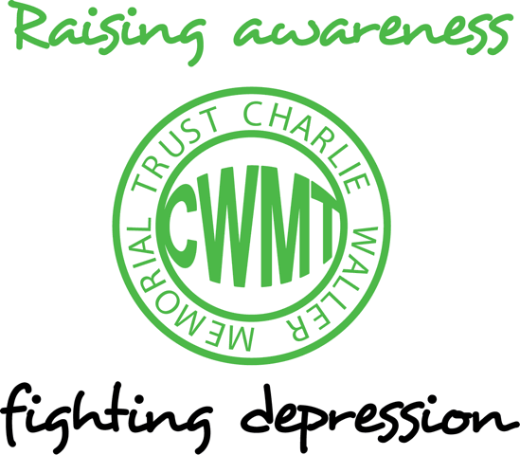

An upstream approach to improving psychological wellbeing
Dr Brian Marien

Prevention or cure?
Zola, an American sociologist, described a scene where a walker strolling along the bank of a river notices a man pulling bodies out of the water. He asks tentatively, “What’s happening?” The man explains, “I am a doctor and I am saving lives, but I am so busy pulling bodies out of the water that I don’t have time to go upstream to see why they are falling in.” Zola used this metaphor to highlight how medical practice in the 60’s and 70’s was predominantly focused ‘downstream’, waiting for people to get ill or develop a disease. Medicine has now moved ‘upstream’, assessing and modifying a wide range of recognised ‘risk factors’ (e.g. elevated blood pressure, blood sugar, cholesterol) that are known to increase the chances of individuals developing disability and disease. Medicine also routinely recommends ‘protective factors’ (e.g. exercise, healthy diet, social support) that can help reduce the incidence of illness and premature death.
The reality is that most of us will experience periods of stress, anxiety, or depression at certain times in our lives. It is a normal response to adverse life events, periods of pressure or distressing experiences. One in 4 people will experience some kind of mental health problem in the course of a year and about one in 10 children have a common mental health problem.
In the UK it is estimated that anxiety and depression account for 40% of underperformance at work, 40% of time off work and 40% of disability. Scientific evidence shows that 44% of people who receive evidence-based psychological treatment recover and around 65% show worthwhile improvement, as well as reduced risk of relapse.
There is a growing focus on moving upstream to protect mental health and reduce the incidence of mental illness.
Mental Health Literacy
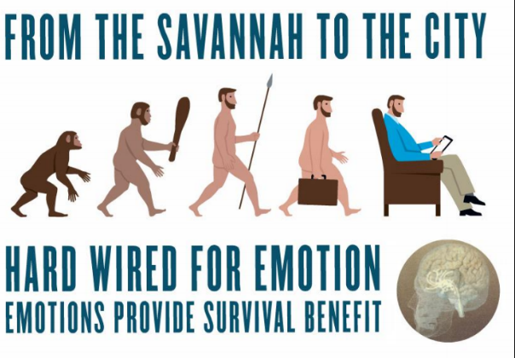
Normalising emotional states improves mental health literacy and reduces stigma. Increasing mental health literacy has been shown to improve mental health . Emotional literacy, an understanding of psychology, and insights into how the brain works can help normalise the impact of emotional states on cognition (thoughts, images, patterns of thinking and information processing), physiology (physical symptoms) and behaviour. Emotions can only really be understood from an evolutionary perspective. We only left the savannah about 80,000 years ago and remain hardwired to emotions that helped our ancestors survive.
Winning- Losing
Different neurotransmitters
Different neural circuits
Different psychological response
Different behavioural response

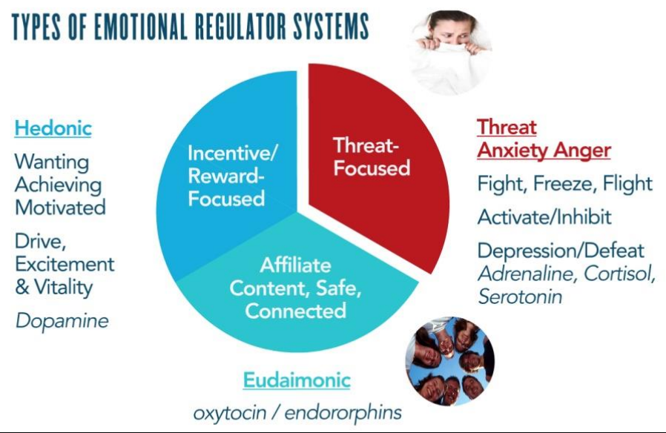
The human brain is made up of over 100 billion brain cells called neurons. Neurons communicate through the release of chemicals known as neurotransmitters (such as serotonin & adrenaline). Different emotions cause the release of specific neurotransmitters in the brain creating ‘emotional memories’.
Later, certain triggers can reactivate the same emotion, wake up the memory, and directly influence how we think, feel and behave. Emotions strongly influence what we pay attention to. When anxious we tend to focus on potential sources of threat. Focusing on real sources of threat helps to improve our chances of survival, it helps to keep us alive and remain in the gene pool.
Imaginary threats, worries or catastrophic thoughts, can create a virtual reality that is capable of hijacking our attention and activating the same powerful threat circuit. Persistent worry maintains activation of the threat circuit and starts to take a heavy cognitive and physical toll.
Emotions influence the memories that come to mind. When we are sad, low or depressed we have better access to more negative memories and impoverished access to positive memories. Revisiting, and dwelling on, past negative events can help to maintain a depressed.
Selective attention and selective memory are recognised as powerful maintaining factors in mood disorder and their modification is central to effective psychological treatment.
The mind –body connection
The evidence linking physical health and psychological wellbeing has accumulated rapidly over the past decade. Stress, anxiety and depression exert a powerful impact on the central nervous system, the immune system, hormone levels, and a range of important metabolic pathways in the body.
The relatively recent discovery of chemical immune messengers, “cytokines”, has revolutionised our understanding of mind/body communication. The relationship is bidirectional. Positive and negative emotional states alter the circulating levels of different cytokines. Cytokines impact on sleep, appetite, mood, memory, cognitive function, energy and motivation.
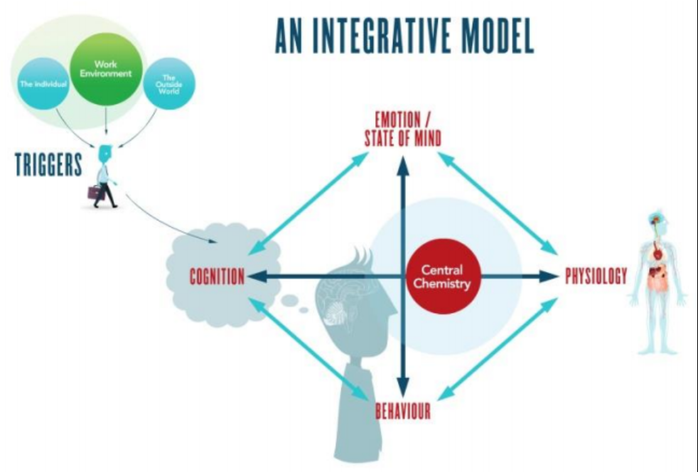
Cytokines act as important mediators between mood states and illness. The discovery of cytokines has accelerated our understanding of the powerful correlation between psychological health and the risk of developing physical and mental health problems.
The cognitive behavioural approach is based on the principle that our emotions change the way we think, how we feel physically, and can alter our behaviour.
Thoughts can trigger chemical changes in the brain and body within a matter of milliseconds. Hearing a noise in the night (trigger) and thinking it is the cat will have a very different impact on brain chemistry, physiology and behaviour than thinking that the same noise is an intruder in the house.
Some of the risk factors for developing mental health problems are linked to our personal genetic makeup and early life experiences. Others such as low self esteem, cognitive vulnerability (negative patterns of thinking), perfectionism, chronic stress, insomnia, intolerance of uncertainty, worry and rumination (repetitive negative thinking) along with certain behavioural patterns (avoidance or withdrawal) are amenable to an upstream approach.
“Neuroplasticity” means the brain’s ability to re-organise itself. The brain forms neural connections in response to new information. These brain connections change in response to experience and can be strengthened by repeated use. So a negative cognitive style is a risk factor for developing mental health problems Persistent worry, negative thinking and rumination contribute to anxiety and depression, and impair problem solving and an individual’s ability to recover from problems or distressing events. Neuroplasticity means that we can re-wire our brain and a positive cognitive style is highly protective.
Moving upstream
Emotional literacy (the ability to manage one’s own emotions and understand the relationship between mood, cognitive style and behaviour) can help to reduce vulnerability to stress, anxiety and depression.
Psychology is not just the study of problems; it is also the study of strengths and resilience. The past decade has seen the emergence of a new field of science, known as “Positive Psychology” (informed by medicine, neuroscience, cognitive and behavioural psychology) that actively seeks to understand how individuals thrive and flourish.
Resilience is a dynamic process that enables an individual to adapt, adjust and recover when they encounter periods of pressure, set-backs or adversity. Resilient individuals adopt ‘a positive cognitive style’, and patterns of behaviour that help build physical, mental and emotional resilience. The good news is that these effective cognitive and behavioural tools and techniques can be learnt.
Optimism and a positive cognitive style are highly protective. A good example is the Penn Resiliency Program (PRP), based on the cognitive-behavioural approach, which has been delivered to over 2,000 school children and shows a significant reduction in of anxiety and depression. There is also robust evidence showing that regular exercise and good social support help improve mental health.
There are real and measurable benefits in moving ‘upstream’ to improve mental health. Psychological wellbeing, optimism and happiness confer significant health benefits, increase life expectancy and improve our social and economic life. (The Depression Report (part funded by CWMT) outlined the economic burden of mental health problems and helped persuade the Government to improve access to therapies).
Personal resilience predicts educational performance better than IQ does because it protects cognitive ability (concentration, memory, decision making and important executive skills). Even relatively mild levels of psychological distress can have a negative impact on cognitive function and performance.
Psychological wellbeing improves work performance. Academic studies show that, employees with positive psychological wellbeing have on average 31% higher productivity, their sales are 37% higher, and their creativity is three times higher. Enlightened organizations are actively seeking to improve the psychological wellbeing of their employees, help build their resilience and optimise their full potential.
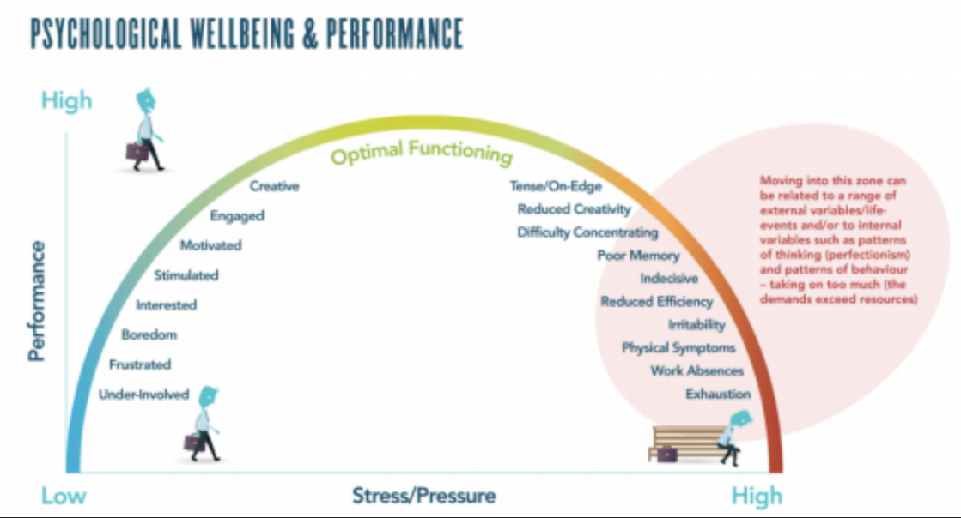
Returning to Zola’s metaphor, a joined-up, integrative approach to mental health, that combines upstream and downstream approaches, would make a powerful and measurable contribution to helping people remain well. We now have a range of psychological techniques that have passed the most rigorous scientific tests of effectiveness.
Providing access to an effective cognitive and behavioural tool-kit, informed by positive psychology, should be seen as a valuable life skill. Mindfulness is a good example of an effective cognitive tool that can protect individuals from mental health problems, by changing negative patterns of thinking.
Developing a structured upstream approach would provide important insights into the various risk factors and protective factors involved in mental health. Building a personal resilience framework, based on proven techniques, could help reduce the incidence of mental health problems and alleviate some of the distress, disability and suffering associated with mental illness. Moving upstream would provide a ‘vaccine of self-awareness’ that enabled more people to thrive, flourish and achieve their true potential.

Dr Brian Marien
Founder and Director of Positive Health Strategies
brian.marien@positivegroup.org
www.positivegroup.org

This article featured in the CWMT Newsletter, issue 28, September 2013

Mental health first aid training in a workplace setting: A randomized controlled trial [ISRCTN13249129] Betty A Kitchener*1 and Anthony F Jorm2. BMC Psychiatry 2004, 4:23 doi:10.1186/1471-244X-4-23)
(Watkins, E. and Baracaia, S. (2001) Why do people ruminate in dysphoric moods? Personality and Individual Differences, 30, 723-34.)
http://www.ppc.sas.upenn.edu/prpsum.htm)
The Depression Report in 2006. http://cep.lse.ac.uk/textonly/research/mentalhealth/DEPRESSION_REPORT_LAYARD2.pdf
See for example ; Mindfulness: a Practical Guide to Finding Peace in a Frantic World – Mark Williams

