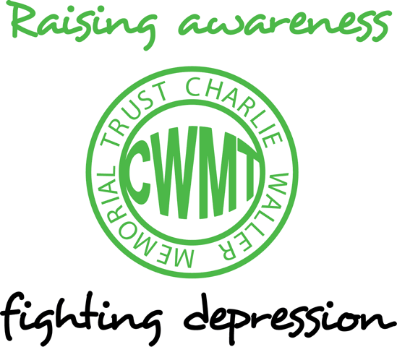

Anxiety

Most people who have had depression will also have experienced intense, disabling anxiety at some point during the course of their illness. One of the most common forms of anxiety is „Generalized Anxiety Disorder‟ or „GAD‟. Dr. Kevin Meares and Professor Mark Freeston at the University of Newcastle are experts in the treatment of Generalized Anxiety Disorder and have recently written a self-help chapter as part of a new book on CBT co-edited by our former Chair Roz Shafran. An extract from the chapter on GAD was printed in „The Times‟ on January 19th 2013. Some of the key points from the chapter are below.
Almost everyone has experienced anxiety at some time in their lives, and to do so is not only natural, but probably quite sensible, too. In some sense, the feeling of anxiety is like a signal to us that we need to take action. If we are walking alone down a dark street and start to feel anxious, we might think, “This is getting spooky, I think I‟ll nip into the pub and call a cab”, so we will be doing something to get ourselves somewhere safe. Anxiety can be “normal” in the sense that it fits the occasion, but it can also be “abnormal” — that is, the anxiety starts to take over our thinking processes and our lives, and makes it difficult for us to function. It is possible that people who experience excessive and distressing levels of persistent anxiety are suffering from a disorder called Generalised Anxiety Disorder or GAD.
The most important feature of GAD is that people experience quite severe anxiety and worry about a wide range of things over long periods of time. Symptoms include:
- finding it difficult to control the worry
- restlessness
- a feeling of being keyed up
- getting easily tired
- difficulty concentrating
- feeling that your mind has gone blank
- irritability
- tension in the muscles
- Sleep disturbance, so that we have difficulty falling or staying asleep, or wake up feeling unrefreshed by our sleep.

People with GAD find it difficult to function normally at home, at work, or elsewhere, because of the extent of the worry. People with GAD tend to worry about the same kinds of things as people without GAD — only they fall into worrying more easily and tend to spend more time worrying. Research suggests that our worry tends to cluster around particular themes. These include our health, finances, relationships, family, work and finally, worry about worrying.
We worry in response to life‟s uncertainties. People who worry find it hard to tolerate uncertainty, and spend a lot of time asking “what if” questions that make the anxiety worse. Typical examples include: “What if my partner has an accident on the way home?” or “What if my report is useless and my boss decides I should get the sack?”
Some worries are realistic (“real event” worries) and need to be dealt with using problem-solving techniques or finding practical solutions to the problem. For example, if I worry about the size of my credit card bill, then this problem exists and my worry is based on a real and present problem. Problem-solving is a well-established treatment for depression as well. Some worries are about things that may never happen (“hypothetical event” worries), and need approach that tackles the worry itself. Sometimes, real event worries spiral into hypothetical event worries. For example, “My neighbours are noisy” could spiral into “I‟ll never be able to sell the house, I‟ll be stuck here for ever.”
Without realising it, we have ideas or beliefs about worry that help to keep it going. These can be either positive beliefs about worry, which cover the way in which people think worry might be helpful and therefore they need to keep doing it.
Examples of positive beliefs would be “worrying shows that I care” or “worrying motivates me”. Or they could be negative beliefs about worry (the ideas that worry is dangerous, which make people more anxious and therefore prone to worry more). A typical thought might be “worrying so much means I am losing my mind”.
Even though you may always have had a tendency to worry — maybe your parents did, too — you can still learn to understand it and get on top of it. Excessive worry is not a part of your personality, and it‟s not something that you should accept as inevitable.
How bad is your anxiety? Answer yes or no:
- Have you always been a worrier?
- If there is nothing to worry about, do you still find yourself worrying?
- Do minor everyday things spiral into major concerns?
- Once it starts, is your worry hard to stop?
- Does worry stop you enjoying life?
- Do you friends or family often suggest that you worry too much?
- Or, do they often tell you to stop worrying?
If you answer yes to at least two of these questions, and if the worry is making it difficult for you to function properly at work, at home or in social situations, then you probably suffer from excessive worry.
SOME METHODS TO HELP
Learn to live with uncertainty Think about how worry or uncertainty has limited the way you live your life. What could be the advantages of accepting a little more uncertainty into your life? Take a moment to think practically about what you could do to introduce a little uncertainty on purpose so that you can learn to tolerate it a bit better. For example, don‟t ask for reassurance on a decision you have made. Stop checking e-mails before sending them. Go to see a film you know nothing about. Let others drive if you always drive yourself; drive yourself if you always let others drive. When you start to make these changes you are likely to feel quite nervous and worried. Try not to let the worry stop you from doing what you have decided to do— anxiety does wear off if people can just sit tight and expose themselves to the things that frighten them.
Deal with real worries properly To overcome your worry it is important to become much more aware of when your worry starts to spiral from real to hypothetical. But if it is about a real current problem, then think about how to solve it. Sometimes, worriers can confuse worrying with solving problems. While it sometimes feels as though we are doing something about our problems by worrying about them, in reality, we are usually not. Problemsolving requires a different style of thinking from worrying. For instance, problem-solving is characterised more by questions that begin “how”, “when”, “where”, whereas worry questions tend to begin with “why” or “what if”. Another way to check the difference is to ask yourself: “Have I come up with a solution, or am I just going over the same problems again and again?”
Do you overanalyse things? A worrier may think of all the possible ways that the problem could be solved and the outcomes of each solution, each generating more problems, which require more solutions, and so on. This results in you getting lost within the labyrinth of alternatives and never solving the problem. Can you limit the time you need to solve a problem?

Or do you perhaps flip-flop between approaching a problem and then avoiding it? This is another common pattern that worriers unwittingly fall into. They approach a problem and then flit between trying to solve it by doing something purposeful and then avoiding the problem. Can you keep engaged with a problem until it is solved?
How to deal with hypothetical worries Now, turn your attention to the type of worry for which you cannot use problem solving: hypothetical event worry. In this type of worry, people imagine scenarios that would be catastrophic if they happened. Then they react emotionally as if these imagined scenarios are real. They feel as terrible as if the things had really happened, even though they haven‟t.
Hypothetical worries typically involve themes of loss of loved ones, rejection by others, breakdown of important relationships, loss of financial security, illness and suffering, and the inability to face or cope with any of these. At the heart of these worries lie our dreams and aspirations, like wanting to be a good parent, or to be in good health, or to have financial security. All of us are afraid when the things we value are threatened. To overcome this, you need to face the things you “see” in your hypothetical worry. Avoidance does not work as a way of managing the fears that are at the heart of our worries. Remember that worries are thoughts based on what is important to us but they are not predictions or premonitions. They are simply thoughts.
To work with your hypothetical event worry, it is important to sit with the feelings without doing anything to make the situation or your feelings better. Learn that they are just thoughts. They are the by-products of your imagination, revolving around things that are important to you.

Extracted from the chapter on ‘Generalized Anxiety Disorder and Worry’ by Kevin Meares and Mark Freeston in The Complete CBT Guide for Anxiety (edited by Roz Shafran, Lee Brosan & Peter J. Cooper). Published by Constable & Robinson, January 2013.

This article featured in the CWMT Newsletter, issue 27, April 2013

