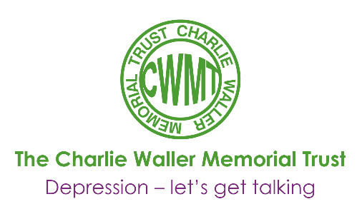
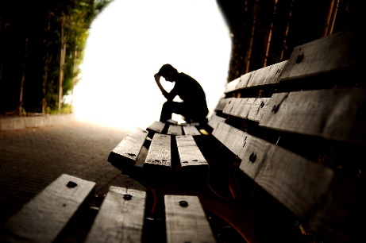

Understanding eating disorders and self-harm
Dr Pooky Knightsmith

Dr Pooky Knightsmith is an associate trainer for CWMT, taking her expertise on self-harm and eating disorders into schools across the UK. Here, she looks at some of the reasons young people turn to self-harm and eating disorders, and how a greater understanding of these can be used to provide sustainable support.
Of the many issues we find ourselves regularly facing when working with young people, self-harm and eating disorders are arguably one of the most prevalent yet also the least well understood. The question I’m most often asked by colleagues is ‘But why?’ and it’s a good question, the answer to which can provide the underpinning of a meaningful, supportive and sustainable relationship with a young person.
There are many different motivations underlying self-harm and eating disorders. In this article, I explore the most common ones and consider how those working with young people might tailor their relationship to provide the most appropriate and sustainable support in each instance.

Control
In my research, I’ve talked to thousands of young people about the motivations underlying their self-harming or eating disordered behaviours. The most common reason I hear is that it’s a way of gaining control. There are few things that adolescents feel they can truly control – but their own body is one of them.
Some adolescents feel that every moment of their life is dictated. Perhaps filled with schoolwork and extra-curricular activities. With little time to just be themselves, they may feel like they have little or no part to play in their own lives.
“I was on a treadmill of school exams and dance exams, none of which I felt that I’d chosen. It felt like there was nothing I could change or control – but I could control what I ate, what I drank and what I did to my body.”
These young people need to realise they do have some control in their own lives and to recognise where and how they can safely assert this control. We can also help them develop the confidence and self-esteem they need to become more assertive and to challenge, rather than accept, the decisions of others where these conflict with internal goals.
Other young people will seek control through food or self-harm because their life is in chaos, often as the result of parental separation or living in care. With their life in free-fall, their harmful behaviours can offer moments of clarity, where they have complete control over one small aspect of their life.
“Life was a mess. There was all this… stuff… just going on all the time. I felt really helpless, but when I burned myself I would feel the opposite. Really powerful and completely in control.”
Providing a safe and structured environment for difficult conversations with family or support workers can be a real help. Often, the young person needs reassurance from their family or carers and an opportunity to understand and explore what’s happening.

Release
Many young people will talk about self-harm as the only method they have for releasing or relieving difficult feelings.
“When I see the blood coming out, it’s like all my problems are coming out.”
“If I’m feeling really angry, it’s the only thing that helps.”
“When I binge, it completely numbs my pain for a while.”
For these young people, our priority is about helping them to recognise and manage difficult feelings. We can work with them to develop a range of different strategies for releasing their feelings whether it’s talking, or art, music or drama. The best approach is one tailored to the individual and which we revisit over time. Basic work around understanding emotions and emotional triggers can be helpful with these young people too.
Escape
Much like how stubbing a toe blocks out all other thoughts and feelings other than how much it hurts, harmful behaviours like cutting, burning, bingeing or purging may have the same effect. This can provide blessed relief if the other things a young person would have been thinking about are constantly causing them misery and pain.
“I had a lot of stuff going on in my head all the time. It was like a load of voices shouting louder and louder to be heard all the time. My thoughts were consumed by them and I couldn’t think of anything else – except for the few moments after I hurt myself. Then I could escape for a little while whilst my thoughts were all about the physical pain I was feeling.”
In this case, we can work with young people to develop alternative escape strategies – sometimes mindfulness techniques can help here. Many young people have talked about the benefits of adult colouring as a way of taking their focus away from everything else; alternatively listening to music very loudly or getting involved with team sports can both have a similar effect.

Punishment
Some sufferers describe a need to punish themselves. This is usually either because they have very high standards of themselves or because they have learned, through a pattern of being abused, that they deserve to be punished.
“If my marks weren’t good enough then I’d go to the toilets at break time and cut myself whilst this voice in my head was calling me stupid and reminding me I’d always be a failure.”
“If I failed a test, I wasn’t allowed to eat for the rest of the day.”
“I would replay situations and want to just die. As I’d think about the stupid things I’d said or done, I’d hit my head against the wall as hard as I could. Almost like I could bang out those memories.”
“I went through a phase of only eating bland or rotting foods. I didn’t feel worthy of anything else.”
In these cases, a key focus is self-esteem. We need to help young people to understand that they do not deserve to be punished. We can begin to help by challenging the negative thoughts and feelings which accompany the need to punish and think carefully about the types of situations that a young person feels warrants punishment. Often, they have set themselves unrealistic standards and will not forgive the slightest slip. Sometimes imagining these behaviours in a friend and asking – “do you think they’d deserve to be punished…?” can help young people to look outside themselves and start to re-evaluate long-standing assumptions.

To feel cared for
Sometimes, young people self-harm in order to access kindness and physical care. Historically we’d associate this behaviour with younger children experiencing neglect, whose physical and emotional needs were not being met at home and who would welcome the attention and support of a school nurse, counsellor or caring teacher.
“It started with an accident – but the nurse was so kind and so careful that I found myself trying to have accidents more. I’d run around the playground as fast as I could, looking for things to trip over so she would look after me. I was forever ‘accidentally’ knocking off scabs so I had an excuse to go to see the nurse. I was six. I don’t think my parents even knew I existed.”
Increasingly, we’re seeing a similar pattern of behaviours in adolescents who appear to have it all: nice home, loving family, a bedroom full of gadgets – but they talk of feeling alone. Often parents are working hard to maintain their lifestyle and there just aren’t enough hours in the day for emotional needs to be met.
“My parents were always working – my school fees were expensive and we had this massive house and the nice car and all that but all I wanted was someone to actually talk to me. To ask me how my day had been and have time to listen to the answer.”
Young people need to understand how to access support and care without the need for cuts, bruises or self-starvation. We can work on helping them understand that they are worthy of care, love and support, whether or not their body physically spells out that need. However, we need to take care to help them identify where this support may come from as, unfortunately, it is currently far easier for the child who is self-harming or restricting their food intake to access appropriate support than it is for the child who is not.
Where a child welcomes the involvement of their family, it can helpful to help them understand that their child is feeling lonely and provide practical suggestions for rebuilding these relationships.

To feel real
Young people who are suffering with depression will often turn to self-harm just to feel real for a little while.
“I was numb all the time. I felt nothing. No feelings of happiness or sadness or anything. Just numb. The only thing I could feel was pain – so I would pull out my hair so I would feel alive. It was like pinching yourself in a dream.”
It can be very hard for people with depression to feel connected with the world and these physical reminders that they are alive can offer a lot of reassurance. We can encourage the young person to replace harmful behaviours with less harmful means of feeling real. Cold can be very effective – clenching ice cubes, eating an ice lolly and thinking about how cold it feels or plunging their hands or face into a bowl of ice water can help young people to feel real for a moment without causing themselves harm
*************
I hope this helps to highlight how behaviours might look similar from one child to the next but the underlying motivations can be very different and that, as this becomes apparent, adapting our support can better enable us to provide meaningful, sustainable help.
Of course, each case is unique and many young people begin their journey with a lack of insight and understanding of their own condition, so it can seem rather like we’re feeling our way in the dark at first. Only once we’ve established trust and helped the young person to develop the skills they need to explore and express their own experiences will we be in a position to begin to understand the underlying issues. At this point, we can begin to work towards developing the skills, strategies and support needed to keep the young person safe, not just this week or next, but for a lifetime.

This is an adaptation of an article written on behalf of CWMT for BACP Children and Young People, a divisional journal of The British Association of Counsellors and Psychotherapists. It has a membership of around 4,500 who are practising counsellors and psychotherapists in a variety of contexts, including schools.

This article featured in the CWMT Newsletter, issue 32, September 2015

