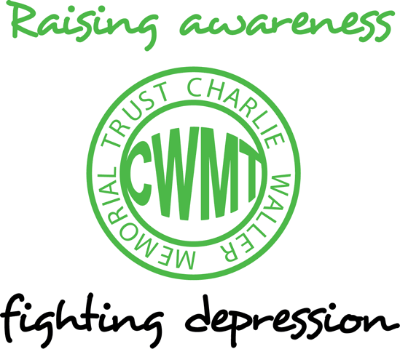
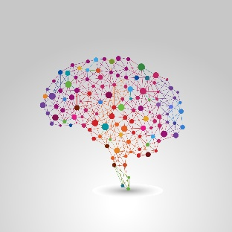

Mood disorders, genetics and the brain
Tom Johnstone PhD

Clinical depression is one of the leading causes of disability and lost productivity in the world and yet despite this, understanding the main underlying factors that contribute to depression remains an elusive goal. In the last decade however, creation of well-equipped and truly multidisciplinary research centres staffed by experts from a wide range of fields is starting to yield promising results into the underpinnings of depression and other mood and anxiety disorders. In particular, the coordinated efforts of clinical psychologists, psychiatrists, neuroscientists, biologists and geneticists has started to cast light on how subtle genetic and other biological differences might render some individuals more susceptible to mood disorders than others even when exposed to similar stressors. The story that is beginning to emerge involves the effects of genes on the basic functions of nerve cells, which in turn change the way our brain responds to stressful events in the environment. Such individual differences even play a role in altering a person’s ability to regulate their emotional responses and affect longerterm change in their mood and emotions.
In the first half of the 20th century it was thought that emotion and mood were a more or less reflexive function of some of the oldest (in an evolutionary sense) parts of our brains, structures buried deep in the centre of the brain and collectively termed the limbic system. Experiments with cats and other animals suggested that the outer layer of the brain – the evolutionarily young cortex – played a role in damping these “animal spirits.” In the latter part of the 20th century some researchers started to get a more detailed picture of the importance of the human cortex in regulating moods and emotions. They found that people who had sustained damage to parts of the prefrontal cortex – the brain regions directly above and behind the eyes – seemed to lack the ability to properly monitor and control their emotions.
By the end of the 20th century, brain imaging technologies had been developed that allowed researchers to study the activity of the human brain in an entirely non-invasive way. In the first decade of this century there has been an explosion of studies examining brain activity related to emotions and moods, with many confirming earlier theories that limbic system structures in the centre of the brain were crucially involved in generating our emotional responses. Researchers including my former colleagues in Madison, Wisconsin in the USA and my current colleagues in Reading have found that regions in the prefrontal cortex became particularly active when research participants are trained to regulate their emotional responses in particular ways, such as reframing the context or meaning of negative pictures to make them less distressing. The more these prefrontal regions become active, the more the limbic structures seemed to be turned down, and the less distressed people feel. We have extended this line of research the regulation of positive emotions as well as negative. Anhedonia – the general loss of positive emotional engagement in life – is a significant but often overlooked factor in depression. Our research has found that while depressed individuals don’t immediately react less to pleasant things, their positive emotional responses are not sustained over time. The results from our research indicate that the ability to maintain positive emotions for more extended periods of time depends on connections between parts of the prefrontal cortex and a structure in the limbic system called the ventral striatum, which is a crucial part of the brain’s reward system. Compared to non-depressed people, those with depression show less sustained activity in the ventral striatum in response to rewarding stimuli, and corresponding reduced connectivity between this brain structure and the prefrontal cortex.
So the prefrontal cortex seems to be crucial for both turning down strong negative emotions and moods, and turning up and maintaining positive emotions and moods, through its connections with structures deep within the brain’s limbic system. The engagement of the prefrontal cortex to regulate emotions is diminished in depression. Not only that; in a sample of non-depressed people, we see large variability within this emotion regulation system, with some people showing greater prefrontal activity and corresponding greater ability to regulate their emotions. Could it be that people with this ability are less susceptible to getting depressed? Why does such individual variability exist? Is it a result of life’s experiences, upbringing, genetics? These are all questions that are being addressed in our research centre and similar centres around the world. On the base of the evidence so far, the answer is perhaps unsurprisingly, a combination of all these things.
Let’s begin with genetics, since our genetic makeup sets the scene for how we develop throughout life. Some of the earliest evidence for a link between our moods and emotions and genetic differences came from the research of Weinberger, Hariri and colleagues at the National Institute of Mental Health in the USA. The researchers examined people with a specific variant of the gene that affects serotonin transport in the brain. Serotonin is one of the brain’s primary chemical messengers; neurons communicate when one neuron releases such a chemical messenger and it attaches to an adjacent neuron. Serotonin transport is the process by which serotonin is recycled, thus allowing such neuronal transmission to continue. Serotonin is thought to be crucial for appropriate regulation of our moods (a reason why the most common medications for depression target the serotonin system), though the precise way in which serotonin acts is not yet well understood. Previous research has shown that people with a particular variant of the serotonin transporter gene have a much greater chance of developing depression as a result of lifetime stressors. Weinberger’s group found that people with the same variant of the serotonin transporter gene showed reduced connectivity between a part of the prefrontal cortex called the cingulate and the amygdala as well as increased amygdala activity in response to negative stimuli. This research thus provides one possible underlying reason why some people might not be able to regulate their moods and emotions as effectively as others: possession of a particular variant of the serotonin transporter gene leads to reduced connectivity between the parts of the prefrontal cortex that regulate emotions and the parts of the limbic system that generate emotions.
Since these promising studies of the serotonin transporter gene, numerous other genetic variants involved in the serotonin system have been identified and their role in mood and mood disorders has been studied. Variants in genes that affect the way serotonin is produced and broken down and how serotonin binds to neurons are all the focus of investigation. In addition to serotonin, genetic variability in the dopamine system – a neurotransmitter involved in reward and positive emotions – is being studied as a possible contributing factor to anhedonia in depression. In fact, the list of candidate genes under study has exploded in the last few years, with a recent review identifying over 25 different genes with variants that are thought to play a role in mood and mood regulation. To make matters more complex, specific combinations of different gene variants is now thought to affect brain structure and function in a manner that single gene variants do not. For example, there is evidence that the serotonin transporter gene variant interacts with a variant of a gene that codes for BDNF – a protein involved in neuron survival and growth – in such a way that a particular BDNF gene variant might protect against the effects of the serotonin transporter gene variant discussed earlier.
Does possession of one or more specific gene variants condemn a person to a life of depression? No, and it’s very important to understand the reasons why. For example, the fact that people who possessed the gene variant showed reduced connectivity in Weinberger’s study tells us little about how that reduced connectivity came into being. It could be a fairly direct effect of altered serotonin transport. Equally, it could be the biological result of a lifetime of highly stressful situations – possession of the gene variant perhaps makes us more susceptible to such stressors and when not effectively dealt with the result might be reduced prefrontal-limbic connectivity.
Genetic brain imaging studies of mood and mood disorders are in their infancy, but they have already given us remarkable insights into the complexity of the brain systems responsible for our moods and emotions. In many ways they have validated the notion that mood disorders do have identifiable biological underpinnings. Certain combinations of gene variants and their interaction with the environment over our lifetime have an impact on the brain systems that allow us to regulate our emotions and can render us unable to effectively regulate our moods. The fact that highly complex gene-environment interactions seem to play such an important role reinforces the need to develop more effective and targeted preventative and therapeutic interventions for depression.
This article featured in the CWMT Newsletter, issue 25, April 2012

