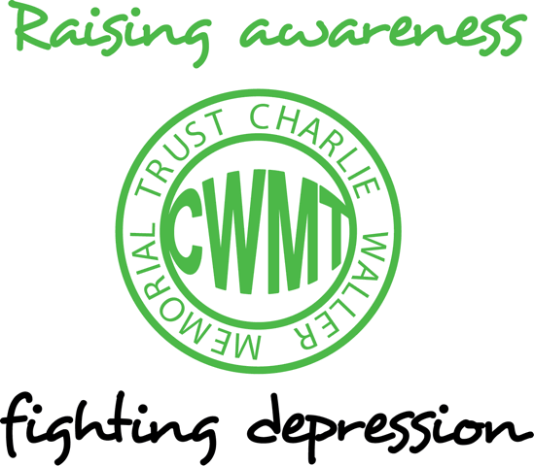

Reflection on how depression could be better acknowledged in GP consultations
Professor André Tylee

Here are a few reflections, which are based on the personal experience of having spent most of my childhood with a parent whose depression went un-recognised by GPs and hospital specialists. It is also based on my professional experience of working for over twenty years as a GP and an academic, seeing patients with depression and teaching and researching into depression. My early research involved filming 47 GPs and analysing their consultations with depressed people who were yet to have their depression overtly acknowledged and most of my reflections are based on this work.
Whether both the doctor and the patient acknowledged someone’s underlying depression, often depended on how the patient presented their symptoms to the doctor concerned. People were up to ten times more likely to have their depression explicitly dealt with if they mentioned it at the very beginning of the consultation. Those who left mentioning it to the very end of the consultation or who didn’t mention it at all (despite completing a questionnaire indicating they probably were depressed in the waiting room), usually did not have their depression acknowledged at all. Also, those people who had depression but also had a physical illness of some sort (usually chronic like arthritis) were five times less likely to have their depression acknowledged in the consultations I analysed, chiefly because the whole focus of attention was on the physical illness concerned. There are some important implications from these findings.
GPs cannot expect people with depression to walk into a consulting room and declare that they have low mood, loss of interest, fatigue, insomnia, have lost weight, lost confidence, feel guilty about things and feel life is not worth living and because of these symptoms they would like the doctor’s opinion on whether they are suffering from depressive disorder requiring medication and/or psychological treatment. More people than ever before are opening the consultation with statements along these lines and it makes the generalists job easier when they do. Researchers in Southampton found that GPs nearly always recognise severe depression and recognition diminishes with reducing severity. Other researchers have shown that over three-quarters of people with depression mention physical rather than emotional symptoms to their GP at the beginning of the consultation. We don’t know for sure but it may only be those with severe depression who mention it early in a consultation.
Many find it difficult to disclose an emotional problem to a doctor and men are particularly bad at this. Research has recently shown that young men with suicidal depression are bad at disclosing even to family and friends let alone health professionals. Perhaps boys need to be encouraged to express emotions more than is traditionally the case and it is not just about teaching them the symptoms of depression.
Whilst it is understandable to want to spend some time determining how receptive the professional is likely to be, my research found that this doesn’t actually help. GPs are better trained to spot non-verbal and verbal cues to underlying distress these days, but are incredibly pressed for time, often seeing 50-60 people in day. They therefore often have to make a hypothesis within the first thirty seconds or so about what is likely to be wrong and it’s severity. Increasing numbers of consultations to improve access within 48 hours to meet government targets can actually diminish the time available to ask people about their lives, families and friends which was the traditional role of the family doctor. Increasing access also decreases the chance of doctors being experts on their patients rather than their diseases. Within the 50-60 people each day are perhaps one or two who will need an ambulance and a handful of people who will need urgent referral to out-patients to exclude for example heart disease, cancer, severe mental illness etc. They therefore place a great deal of emphasis on what is said at the outset of the consultation and only generally have time for one problem per consultation, which for many of the 50-60 people will be chronic longstanding conditions like diabetes, arthritis etc. It is increasingly difficult, therefore, to find time in a consultation for a second problem to be properly addressed so that often a further appointment is necessary to continue the assessment. If a patient does have an idea that they may be depressed it is advisable to say so, and why, at the very beginning of a consultation so that the routine chronic disease management of the other physical condition can be put aside for a while. There is little time to properly review the patient who has returned from hospital having been told all the tests were normal and there is nothing wrong. This accounts for 50% of all patients referred to hospitals for tests and a great proportion have underlying psycho-somatic problems linked to depression or anxiety. Money spent on unnecessary tests could often be better spent on proper initial psychological assessment in many cases, particularly as hospital investigation can in many people exacerbate underlying anxiety states despite reassurance.
There is a well-known phenomenon of patients saying, “by the way, doctor...”. This is when the real reason for the encounter is mentioned only as they have their hand on the doorknob to leave the consultation. I have video-taped doctors responding positively and negatively to this gambit by the patient (which is often subconsciously done) and it is a risky strategy if done consciously and depends on the doctor’s goodwill and numbers remaining in the waiting room. Most patients tend to open with physical symptoms yet GPs generally like to respond to a clear opening gambit by a patient and do not expect patients to come in with a “physical ticket of entry” these days. It can be very helpful to rehearse the opening statement with someone or to take a list of the relevant symptoms. There was a successful campaign by the British Diabetic Association few years ago, consisting of the main symptoms of diabetes and encouraging them to go to the doctor if they had thirst, frequent urination and tiredness. The Charlie Waller Memorial Trust has produced something similar for depression, in the form of an excellent poster and a booklet but this needs to be on advertising hoardings and bus shelters in my opinion to gain greater public awareness.
There is however, a huge issue of stigma. In a recent European survey of six countries I was involved in, people were asked about depression in their own homes. Seventeen per cent had had some form of depression in the previous six months yet only half had sought help from their doctors. It is still the case that some employers discriminate against depressed employees and the employment of people with depression will be the subject of a forthcoming report by the Social Exclusion Unit in the Office of the Deputy Prime Minister. The issue crosses several government departments and the report will recognise the crucial role of primary care.
In conclusion, I hope these reflections are of use to the supporters of the Trust in helping anyone who may have as yet undisclosed depression to get earlier acknowledgement and help. We know that the earlier help can be obtained, the better, and that for most people depression is eminently treatable in a primary care setting. It is worth establishing when registering with a practice or subsequently, which of the doctors or nurses in the practice have an interest in mental health, and there is no substitute for local “word of mouth”. As we are moving to the accreditation and validation of practices rather than individual practitioners, all sizeable practices with several staff should be able to provide this sort of information.

Professor Andre Tylee
Insitute of Psychiatry

This article featured in the CWMT Newsletter, issue 10, June 2004

